file1.srt is the subtitles exported by clipping. Many words are quite different from the original script.docx. Proofread the difference between the original script and the subtitles through the following two steps:

1. batch replacement
2. The words that need to be replaced in batches are added to replacedict.xlsx, column A is the old word, and column B is the new word
3. Call pretreatsrt.py, replace the old words in file1.srt with new words in batches, generate file1-1.srt, mainly replace the words with the connector ‘-’ consistent
4. fine proofreading

file1-1.srt is the version to be proofread, file3.srt is the version after proofreading, and script2.docx is the original lecture. Use with Beyond Compare to compare file1-1.srt and file3.srt, when the execution stops:

1. Display the difference between the subtitle srt and the original
2. Beyond Compare automatically finds the next difference. Found the difference, the original is one-click, and the subtitle is one click
3. Solution: Manually add a ‘-’, or replace it in batches
4. Reference to the original, do not need to be opened in actual use

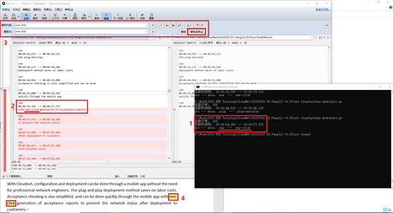

\*If batch problems are found, it is recommended to add to the replacedict.xlsx in step 1, and re-execute step 1, so that

Accumulate “replacement dictionaries” to improve efficiency for follow-up work